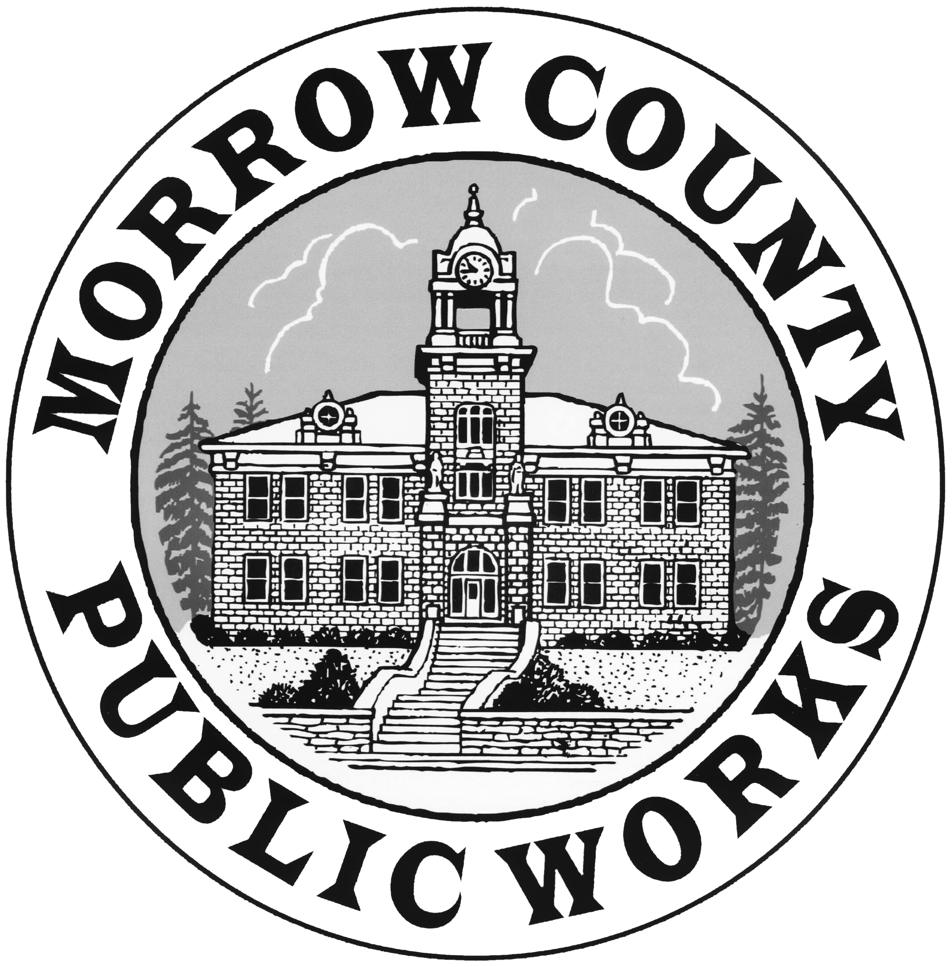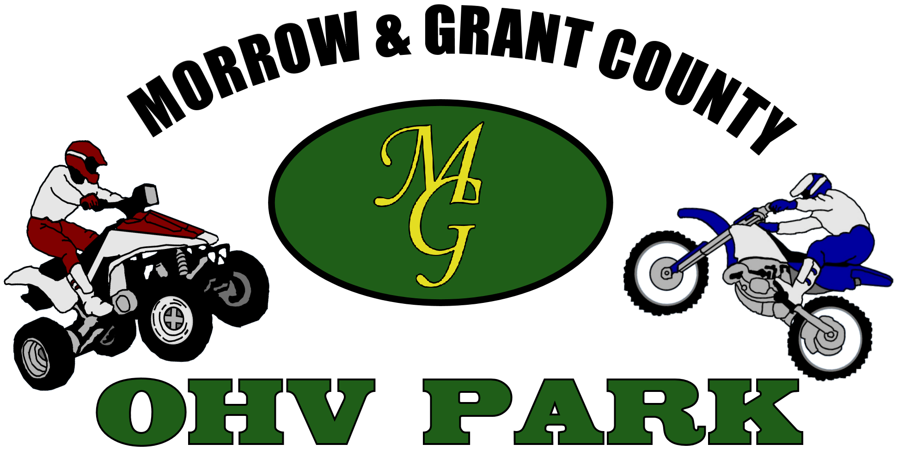
Morrow / Grant County OHV Park Special Elk Youth Hunt
for youth Ages 12 – 17
Application

MUST BE turned in by Tuesday, October 21, 2025 at 4:00 p.m. to
Irrigon Government Center Attention Parks 215 NE Main Ave Irrigon, OR 97844
Morrow County Public Works Attention Parks P.O. Box 428 Lexington, OR. 97839
General Second Season, Spike Only Elk, Nov. 08 – Nov. 16, 2025.
(Successful applicants will need to purchase any and all licenses, tags, and items necessary for the youth hunt. Morrow County only provides access to hunting area for the Youth.)

Name _________________________________________________________________
First --- Middle Initial --- Last

_________________________________________________________________
Physical Address (Street Address)

_________________________________________________________________
Mailing Address (if different from Physical Address)

_________________________________________________________________
City, State ZIP Code

Age. _________________ Need to be between ages 12 and 17 at time of youth special hunt
or *participating in the ODFW Mentored Youth Hunter Program.
Phone _________________ Alternate Phone _________________

Are you a Morrow or Grant County Resident?
VALID Oregon Hunting License (REQUIRED) and must be included with submitted application.
YES __________ NO ____________ if no what County _______________
Is a copy of current hunting license included with application? YES _____ NO _____
A copy of your current hunting license showing Morrow or Grant County residence is required with application.

Have you completed a Hunter Education Course?
YES __________ NO _____________
Attach/Include copy of Hunter Education certificate

Have you participated in this hunt in prior years? YES _______ NO ______
If Yes, were you successful?
YES _______ NO ______

By signing below, I acknowledge that my son or daughter is engaging in a dangerous activity, a resident of Morrow or Grant County, Oregon and that I give my permission for my son or daughter to take part in the youth hunt. I further acknowledge that I am aware of what steps have been taken to maximize the safety of the participants, and hereby release Morrow and Grant County of any liability and hold the Counties and its employees and representatives harmless from any potential legal action that I believe I would otherwise be entitled to whether or not I believe additional safety steps could have been taken. By signing this document, I understand that a successful applicant will be required to have a valid Oregon hunting license, purchase a second season elk tag, follow local, state, and federal rules, laws and guidelines for the hunt. I give permission to Morrow and/or Grant County to use the above-named applicant’s photograph and name in any and all promotional material and publications without notification or compensation for use of such documents or images.
Applications Due OCTOBER 21, 2025 @ 4:00PM

Return applications to:
Irrigon Government Center: Attn Parks
215 NE Main Ave Irrigon, OR 97844
Morrow County Public Works: Attn Parks
365 West Highway 74 Lexington, OR 97839
E-Mail: mcparks@morrowcountyor.gov
Phone: 541-922-6481
_________________________________________
Signature of parent/Guardian Date

_________________________________________
Printed Name of Parent/Guardian

