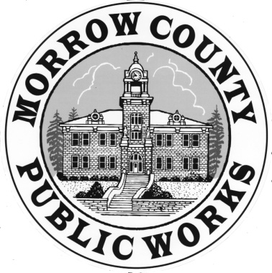 | PUBLIC WORKS DEPARTMENT  Airport General Maintenance Road Department Parks Waste Management
365 W. Highway 74 Matt Scrivner Eric Imes
P.O. Box 428 Director Asst. Road Master
Lexington, OR. 97839
Phone: (541) 989-9500 Sandi Pointer Kirsti Cason
Fax: (541) 989-8352 Management Asst. Administrative Asst.

INVITATION TO BID

For
MORROW COUNTY
2018 IONE – BOARDMAN PAVING PROJECT
MORROW COUNTY PUBLIC WORKS DEPARTMENT
MORROW COUNTY, OREGON
August, 2018

ADDENDUM #1
Issued August 23, 2018

Notice to Bidder’s – This addenda has been issued to correct and or revise the following:

The bid closing change time. Bids will be received until 9:00 a.m. on Monday, August 27, 2018. Bids will be opened and publicly read at 9:05 a.m. on Monday, August 27, 2018/ First tier subcontractor, disclosure forms will be accepted until 11:00 a.m.

